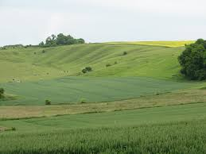
Report to the Parish Council Meeting
to be held on 11th March 2019

PLAN PROGRESS:
February 28th saw the end of the District Council’s [VWHDC] ‘publicity period’ for the Neighbourhood Plan, and while I had hoped to be able to provide the promised result to the parish meeting, as of today it has yet to be received – hopefully this we change by the time of the meeting.
The closing date for quotations from canvased examiners to VWHDC was 4th inst. and we have since been provided with a ranked list of potential appointees, the examiner being recommended by VWHDC being an Andrew Ashcroft. We have in turn confirmed that we have no objections to his appointment meaning that [hopefully] the next stage of the process can commence. Only then can we press for an indication of the probably timing of the referendum, but regrettably such requests & feedback will still need to be channelled through VWHDC.
Up until now the steering group have been able to control programme to a large degree, whereas now we are entirely dependent on third parties, a situation that we are finding particularly frustrating!

PLAN FUNDING:
VWHDC remain unforthcoming in response to our requests for additional funding, but we do at least now have a named ‘lead officer’ and our request has been resubmitted directly to the new officer together with supporting arguments as to why it is required – fingers crossed!!!

Cliff Davies
6th March 2019

