Very good news
We can report that the Parish Council [APC] has arranged for a replacement to the shopperbus service that will take over from 1st April 2020, when the current service ends. The APC will be working with UBW [the Uffington Community Bus Association], using the minibus owned & managed by them. The service will run exclusively between our parish and Swindon centre on Friday afternoons, and will accept pensioners bus passes or will cost £5,80 return - i.e. exactly the same as the current shopperbus fare – meaning there will be no surcharge.

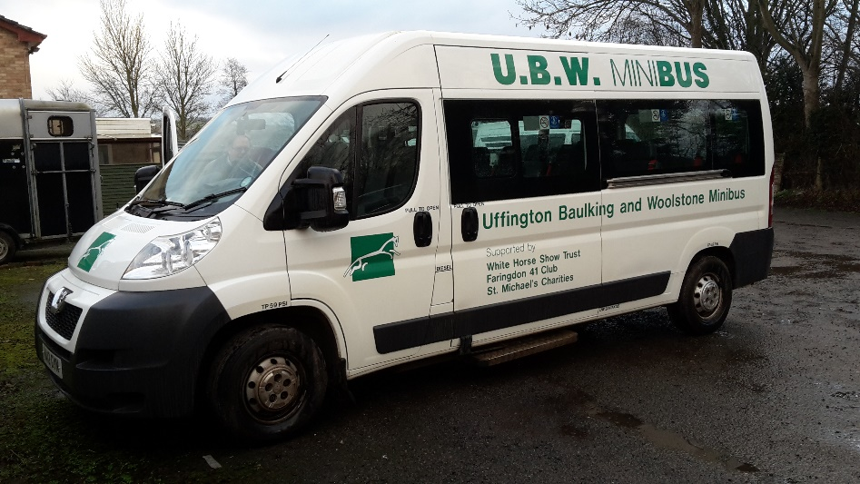
The new Community Service vehicle

We would strongly encourage all current users, or anyone that feels this service might be of use to them, to inform a member of the council or ring either Peter Cowx [710 251]) or Cliff Davies [710 712] as soon as possible to receive a registration form and further details.

Cliff Davies
Email: chairman@ashbury.org.uk
Mob: 07802 717 738

