REPORT TO PARISH COUNCILS JANUARY 2023

FROM CLLR Yvonne Constance

GENERAL OCC REPORT

CLIMATE LOCKDOWN

Conspiracy theorists have cunningly linked OCC plans to create ’15-minute neighbourhoods’ with the plans to introduce six traffic filters that will divide the city of Oxford.
- An example is here: https://www.youtube.com/watch?v=wkZDcVFIxRI
- And the OCC rebuttal is here: https://www.youtube.com/watch?v=W8Dn8MWpv-U
- Regrettably, the fake messaging has frequently been believed and has resulted in threats to councillors and staff: https://www.bbc.co.uk/news/uk-england-oxfordshire-64001776

THE TRUTH: NO LOCKDOWN BUT FILTERS TO SPLIT OXFORD INTO FOUR SECTORS

The truth behind the ‘Climate Lockdown’ scare is that OCC plans to spend £6.5m on traffic filters that will split Oxford into four sectors: North, South, West and East. When the traffic filters are operating, for cars without a permit, movement within each sector is unrestricted, but direct movement between sectors is not possible and requires use of the ring road. Affected motorists will face much longer journey times and distances. The intention is to force a change in behaviour. At the Cabinet meeting on 29th November 2022, a record number of individuals and organisations spoke passionately for and against the highly controversial proposal. The meeting was attended by police armed with tasers and security guards. The chamber had to be cleared at one point. The proposal was approved by Cabinet. The Conservative Opposition has grave concerns about the proposal but condemns the misinformation that is being spread and the resultant abuse suffered by councillors and employees. Many supporters of these measures now concede that they have been poorly planned, maximising the damaging effects of Low-Traffic Neighbourhoods, bus gates and Botley Road improvements works to motorists and businesses in Oxford.

COUNCIL BUDGET FOR 23/24

The Budget process is nearing conclusion, and it is likely the administration will impose a 5% increase in Council Tax on residents. In terms of proposed Directorate spend, a staggering 71% will go on Social Care (Adults £221.3m, Children's £164.9m, total Directorate £544m). As a proportion of gross expenditure (excluding schools) it will be around 52% of c£750m. By way of comparison Highways & Transport will get just 8%.

CHILDREN SERVICES CURRENTLY £14.5M OVER BUDGET OF £149.1M

The Children’s Services budget for 22/23 is £149.1M. As of October 2022, the latest forecast actual spend is £163.M – an overspend of £14.5M. While there is no question that vulnerable children must be protected, the individual costs are staggering. A typical mainstream residential placement is £5,100 per child per week. Costs for children who need significant support can be as high as £20,000 per child per week – pro-rata that is £1m per child per year. Conservatives are questioning whether best value is being achieved and what action is being taken to bring down these extraordinary costs. Despite such questions over value for money, the Council is consulting on a budget that would see Council Tax increase to pay for an 8.3% cash rise in Children’s Services spending.

OCC APPOINTS NEW CHIEF EXECUTIVE ON £225,000 PA

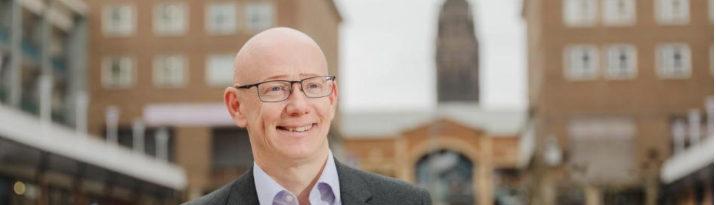

Dr Martin Reeves has been named as the new Chief Executive of OCC. Dr Reeves is expected to take over from Interim Chief Executive, Stephen Chandler, in the Spring. The move means the Council will have been without a permanent Chief Executive for over a year, following Mr Chandler’s engagement as an Interim in February 2022, when the process of ending the partnership between OCC and Cherwell District Council began. Dr Reeves joins from Coventry City Council where he has been Chief Executive since 2009. From 2008 - 2009 he was Chief Executive of Bedfordshire County Council, after serving as Assistant Chief Executive there from 2006 - 2008. He will be paid a salary of £225,000 pa. Not only do Conservatives question whether Town Hall chiefs should be paid such salaries but they also continue to raise the issue of the lack of urgency surrounding the recruitment of a permanent Chief Executive.

CAR PARK ‘LIVING WALL’ THAT COST COUNCIL-TAX PAYERS £30,000 NOW REMOVED

The strange structure that appeared in the car park in front of County Hall during August, taking up two valuable car parking spaces intended for visitors on county business, has now been removed. Apparently, it was a ‘living wall’ and the aim was to understand the impact of plants on air quality in the car park. The cost of this five-month project to Council Tax payers was £30,000. | 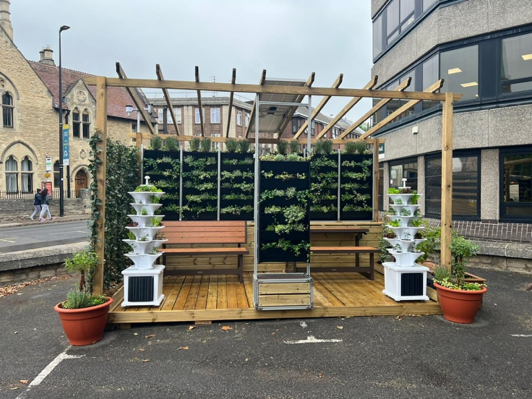

OCC RESOLVES TO IMPROVE SERVICE FOR CHILDREN WITH SPECIAL NEEDS

At the 13 December Full Council meeting, the council acknowledged the difficulties experienced by certain parents and students in the delivery of its SEND service and paid tribute to the testimonies of parents heard at Full Council on 1 November 2022. Councillor Eddie Reeves, Leader of the Opposition, said: “This is an issue of national and indeed grave concern and Oxfordshire does not compare that favourably to other counties and certainly not to other comparable local authorities – we are letting parents, pupils and professionals down if we don’t acknowledge that. We have over 5,000 children and young people with educational health plans in this county – that has grown of a quarter in the past three years. We must ensure that assessments are undertaken promptly and we must ensure that recommendations are subsequently acted upon promptly

